**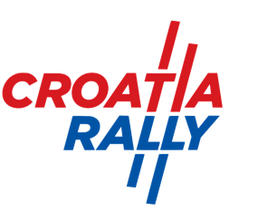****

##### Route Note Car REGISTRATION FORM (Only for competitors in WRC and WRC2)

This form must be filled in and sent by email ([info@rally-croatia.com](mailto:info@rally-croatia.com)) before the administrative checks.

|  |  |
| --- | --- |
| **THIS Route Note car supports CAR NUMBER:**  The route note cars must be as defined by Article 9.6 of the 2021 FIA WRC Sporting Regulations and use the speed control device as fitted for reconnaissance. | *Comp. No.* |

## DETAILS OF THE Route Note CAR

|  |  |
| --- | --- |
| Make |  |
| Model |  |
| Registration no. |  |
| Colour |  |

## DETAILS OF Route Note CAR DRIVER Route Note car CODRIVER

|  |  |  |
| --- | --- | --- |
| Surname |  |  |
| Name |  |  |
| Mobile phone during the event |  |  |

**We herewith acknowledge and accept the organiser’s conditions without reservation.**

**DECLARATION OF INDEMNITY**

My participation as Route Note Car in the WRC Rally Croatia 2021 is at my own risk and I will not hold the Organisers, its Officials, the FIA and the CAKF responsible for any accidents, injuries etc. during the rally (cf. WRC Rally Croatia 2021 Supplementary Regulations). I also declare that I have full knowledge of the rules and regulations issued by the FIA and the organiser covering and governing motor racing in all its aspects and I guarantee to respect all such rules and regulations, without exception.

**For the Competitor:**

|  |  |  |  |
| --- | --- | --- | --- |
| **Full Name** | **Position of Authority** | **Date and Place** | **Signature** |
|  |  |  |  |

|  |  |
| --- | --- |
| **Route Note Car Driver’s Signature** | **Route Note Car Co-driver’s Signature** |
|  |  |